What is FIRST and FLL?
FIRST (For Inspiration and Recognition of Science and Technology) is an organization that holds robotics competitions that challenge engineering and creative skills. FIRST was founded in 1998 by Dean Kamen, and strives to inspire the next generation to be innovative, and to encourage the development of self-confidence, communication, character, and leadership skills.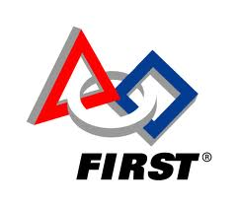
There are 3 divisions in FIRST: FLL (FIRST LEGO League), FTC (FIRST Tech Challenge), and FRC (FIRST Robotics Competition). FLL was created by Dean Kamen & Kjeld Kirk Kristiansen to teach teams to create ideas, solve problems, overcome obstacles, and gain confidence. During competitions from the local level to national levels, teams compete in both robot and research competitions based on the season’s themed challenge. LEGO Mindstorms robotics sets are used to build & program a unique autonomous robot, made entirely out of LEGO pieces. Topics over the years have ranged from the biomedical field to nanotechnology. 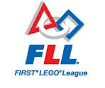

Core Values:
- We are a team.
- We do the work to find solutions with guidance from our coaches and mentors.
- We know our coaches and mentors don't have all the answers; we learn together.
- We honor the spirit of friendly competition.
- What we discover is more important than what we win.
- We share our experiences with others.
- We display Gracious Professionalism® and Coopertition® in everything we do.
- We have FUN!
Gracious Professionalism: This is a motto of FIRST Robotics. All teams are expected to show behavior consistent with being both gracious and professional during a competition, such as being helpful to other teams, good sportsmanship, cooperating with volunteers/officials, etc.

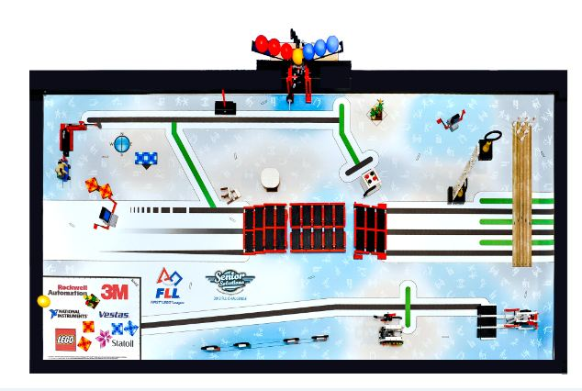Research: This year's project involves finding a problem that some seniors have that others don't. Teams are to find an innovative solution to that problem, and present it to judges at competition. This process occurs with the guidance of a senior partner.

Robot:
- LEGO NXT Mindstorms robotics system.
- Robot and field completely made of LEGO pieces and NXT parts.
- NXT-G programming software. (highly image-based, uses block-like modules)
- Multiple missions on a field to accomplish
- We get 2 minutes and 30 seconds to perform as much as possible with an autonomous (not remote-controlled) robot

For more information go to:
- Our team website: fllteam116.weebly.com
- Official FLL website: firstlegoleague.org
- Los Angeles Region FLL website: fll.larobotics.org
**For more links go on our website under resources -> links**

Team Email: fllteam116@gmail.com

